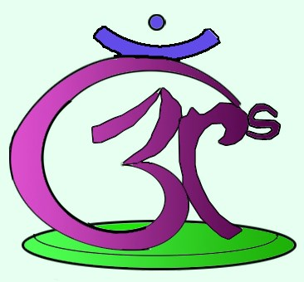

RELAX.REPLENISH.RENEW.
REGISTRATION FORM
NAME:
MAILING ADDRESS:
______________________________________________________
EMAIL/PHONE:
AGE:
WHAT AREA OF EDUCATION DO YOU WORK IN?
_______________________________________________________

WHAT ARE YOUR REASONS FOR ATTENDING THE RETREAT?
________________________________________________________

WHAT EXPECTATIONS DO YOU HAVE ABOUT THE RETREAT?
_______________________________________________________
EXPERIENCE WITH (please check all that apply):
- Yoga __________________________________________
- Mindfulness __________________________________
- Meditation ____________________________________
GENERAL OVERALL HEALTH (PHYSICAL, MENTAL, EMOTIONAL)
________________________________________________________
________________________________________________________
________________________________________________________

RELAX.REPLENISH.RENEW.

ALLERGIES/DIETARY NEEDS
________________________________________________________
NEXT OF KIN (NAME & PHONE NUMBER)
_______________________________________________________

PAYMENT INFORMATION (please circle)
- Cash
- Cheque (To Jacqueline Shoemaker Holmes or Anita Mitra)
- e-Transfer

PLEASE PROVIDE ANY ADDITIONAL INFORMATION YOU WOULD LIKE US TO KNOW
__________________________________________________________
__________________________________________________________
__________________________________________________________

CANCELLATION POLICY
Please note that if unexpected circumstances arise, you are welcome to cancel up until Friday August 1st, 2014 and will receive a full refund minus a $25 registration fee. After this date registration and fees are final.

Contact Jacqueline Schoemaker Holmes at 613-222-4042 or Anita Mitra at anita.mitra@ucdsb.on.ca with questions or for further information/assistance.

